**AI RESUME SCANNING AND CANDIDATE RANKING SYSTEM**

A Project Report

submitted in partial fulfillment of the requirements

of

AICTE Internship on AI: Transformative Learning

with

TechSaksham – A joint CSR initiative of Microsoft & SAP

By

**BHOOMIKA R**

**bhoomikar21@gmail.com**

Under the Guidance of

**SAOMYA CHAUDHURY**

**ACKNOWLEDGEMENT**

We would like to take this opportunity to express our deep sense of gratitude to all individuals who helped us directly or indirectly during this thesis work.

Firstly, we would like to thank my supervisor, **SAOMYA CHAUDHURY** for being a great mentor and the best adviser I could ever have. His advice, encouragement and the critics are a source of innovative ideas, inspiration and causes behind the successful completion of this project. The confidence shown in me by him was the biggest source of inspiration for me. It has been a privilege working with him for the last one year. He always helped me during my project and many other aspects related to the program. His talks and lessons not only help in project work and other activities of the program but also make me a good and responsible professional.

#### **ABSTRACT**

In the modern recruitment landscape, hiring managers face challenges in efficiently screening and ranking candidates due to the overwhelming number of applications. Traditional resume screening methods are time-consuming, prone to bias, and may overlook qualified candidates. To address this issue, our project, **AI Resume Scanning and Candidate Ranking System**, leverages artificial intelligence to automate and enhance the recruitment process.

The primary objective of this system is to streamline candidate evaluation by analyzing resumes based on predefined criteria such as skills, experience, education, and job relevance. The AI model extracts and processes key information from resumes using **Natural Language Processing (NLP)** and **Machine Learning (ML)** algorithms. Candidates are then ranked based on a weighted scoring system, ensuring fair and efficient shortlisting.

The methodology involves **data preprocessing**, where resumes are converted into a structured format, followed by **feature extraction** to identify relevant skills, experience, and qualifications. The system then applies a **ranking algorithm** that assigns scores based on job-specific parameters. The model continuously improves through machine learning techniques, refining ranking accuracy over time.

Key results demonstrate that AI-driven resume screening significantly reduces recruitment time while improving the accuracy of candidate selection. The system minimizes human bias and ensures that the most qualified applicants are highlighted, increasing efficiency for hiring managers.

In conclusion, this project presents an innovative solution to the challenges of manual resume screening. By integrating AI into the recruitment process, organizations can optimize candidate evaluation, reduce hiring costs, and make data-driven hiring decisions. Future enhancements may include integration with applicant tracking systems (ATS) and sentiment analysis to assess candidate intent and personality traits.

**Keywords**: AI, Resume Screening, Candidate Ranking, NLP, Machine Learning, Recruitment Automation.

**Chapter 1.**  **Introduction 1**

1.1 Problem Statement 1

1.2 Motivation 1

1.3 Objectives 2

1.4. Scope of the Project 2

**Chapter 2.**  **Literature Survey 3**

**Chapter 3.**  **Proposed Methodology**

**Chapter 4.**  **Implementation and Results**

**Chapter 5. Discussion and Conclusion**

**References**

**LIST OF FIGURES**

|  |  |  |
| --- | --- | --- |
| **Figure No.** | **Figure Caption** | **Page No.** |
|  | **AI Resume Scanning and Candidate Ranking System** | **2** |
|  | **Methodology of AI Resume Scanning and Candidate Ranking System** | **5** |
|  | **output 1 of AI Resume Scanning and Candidate Ranking System** | **6** |
|  | **output 2 of AI Resume Scanning and Candidate Ranking System** | **7** |

**CHAPTER 1**

**Introduction**

* 1. Problem Statement

The traditional resume screening process is time-consuming, prone to human bias, and inefficient in handling large volumes of applications. Recruiters often spend significant time manually reviewing resumes, which may result in overlooking qualified candidates or unintentional bias affecting hiring decisions. Additionally, keyword-based filtering used in Applicant Tracking Systems (ATS) may discard potential candidates who do not use exact matching terms. As companies strive to improve hiring efficiency and fairness, there is a need for an automated, AI-driven solution that can accurately evaluate and rank candidates based on their qualifications, skills, and experience.

1.2 Motivation

With the increasing number of job applications for each position, companies require an intelligent system to optimize the recruitment process. The AI Resume Scanning and Candidate Ranking System was chosen to address this growing challenge by integrating artificial intelligence to improve the efficiency and fairness of candidate selection. This system can be applied across various industries, helping HR teams and recruiters automate resume screening, reduce bias, and make data-driven hiring decisions. The impact of such a system includes faster hiring processes, cost reduction, improved candidate experience, and enhanced recruitment accuracy.

1.3 Objective

The primary objectives of this project are:

* To develop an AI-based system that can scan and analyze resumes efficiently.
* To extract relevant information such as skills, experience, and education using Natural Language Processing (NLP).
* To rank candidates based on predefined criteria using Machine Learning (ML) algorithms.
* To reduce manual effort and bias in the recruitment process.
* To enhance decision-making for hiring managers through automated candidate shortlisting.

1.4 Scope of the Project

The AI Resume Scanning and Candidate Ranking System focuses on automating resume evaluation and ranking based on job relevance. The system will support multiple resume formats (PDF, DOCX) and extract key details for analysis. It will employ NLP and ML techniques to assess candidate suitability and generate ranked lists for recruiters.

Limitations:

* The system relies on structured data; poorly formatted resumes may not be processed accurately.
* It may not assess soft skills or personality traits, which are crucial for certain roles.
* The accuracy of ranking depends on the quality of training data and predefined criteria.
* The system does not replace human judgment but serves as a decision-support tool for recruiters.

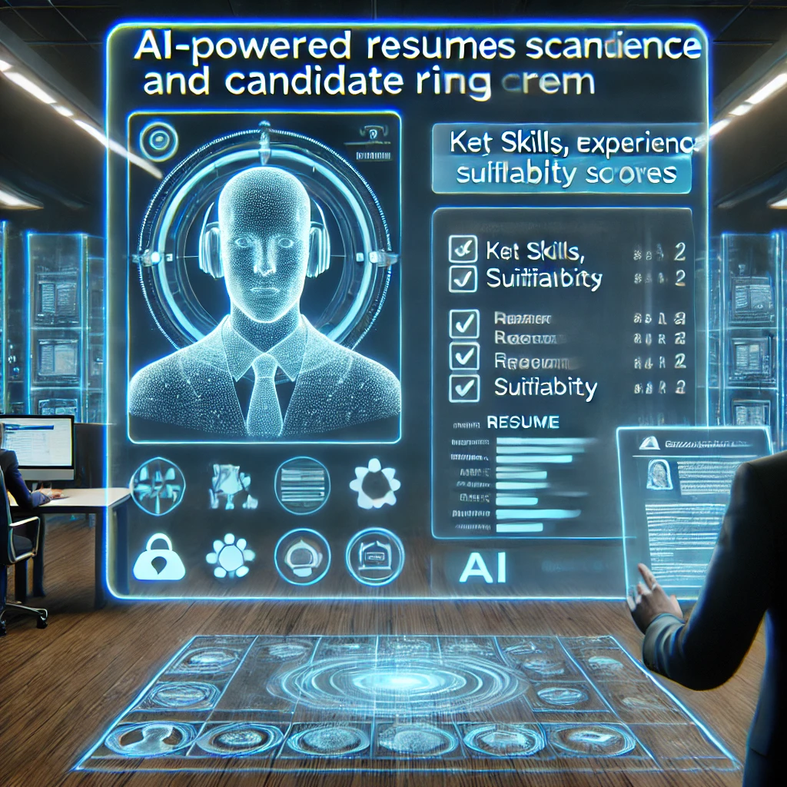

Fig1 :- **AI Resume Scanning and Candidate Ranking System**

**CHAPTER 2**

**Literature Survey**

2.1 Review of Relevant Literature

The automation of resume screening and candidate ranking has been an area of growing interest in artificial intelligence and human resource management. Research in Natural Language Processing (NLP) and Machine Learning (ML) has significantly contributed to developing intelligent recruitment systems. Previous studies have explored automated resume parsing, keyword-based filtering, and AI-driven ranking mechanisms to streamline hiring processes.

2.2 Existing Models, Techniques, and Methodologies

Several methodologies have been proposed and implemented to address automated resume screening:

* Rule-Based Systems: Traditional ATS relies on predefined keyword matching and Boolean searches to filter resumes. However, these systems struggle with contextual understanding.
* Machine Learning-Based Models: Supervised and unsupervised ML algorithms such as Naïve Bayes, Support Vector Machines (SVM), and Decision Trees have been used to classify resumes based on experience, skills, and job relevance.
* Natural Language Processing (NLP) Techniques: Named Entity Recognition (NER), TF-IDF (Term Frequency-Inverse Document Frequency), and Word Embeddings (Word2Vec, BERT) help extract meaningful insights from unstructured resume data.
* Deep Learning Approaches: Neural networks, including Recurrent Neural Networks (RNNs) and Transformers, have been applied for semantic analysis of resumes, improving ranking accuracy.

2.3 Gaps in Existing Solutions and Proposed Enhancements

Despite advancements, existing systems have several limitations:

1. Limited Contextual Understanding: Many ATS systems struggle to interpret resumes in different formats and contexts, leading to inaccurate filtering.
2. Bias in AI Models: Machine learning models may inherit biases from training data, potentially leading to discriminatory hiring outcomes.
3. Lack of Soft Skills Evaluation: Most existing models focus on technical skills but do not assess personality traits or soft skills.
4. Static Ranking Criteria: Traditional ranking systems use fixed-weight scoring, which may not adapt to dynamic job requirements.

:

**CHAPTER 3**

**Proposed Methodology**

3.1 System Design

The AI Resume Scanning and Candidate Ranking System follows a structured pipeline for processing resumes, extracting relevant features, and ranking candidates based on predefined criteria. Below is the system architecture diagram:

System Architecture Diagram

Architecture Components:

1. User Interface (UI):
   * A web-based platform where recruiters upload resumes and set job-specific criteria.
2. Resume Processing Module:
   * Converts resumes (PDF/DOCX) into a structured format.
   * Extracts candidate information (name, contact details, experience, education, skills) using Natural Language Processing (NLP).
3. Feature Extraction & Preprocessing:
   * Removes unnecessary content (headers, footers, special characters).
   * Applies Named Entity Recognition (NER) to identify key attributes.
   * Uses TF-IDF and word embeddings (BERT, Word2Vec) for contextual understanding.
4. Candidate Ranking Module:
   * Uses Machine Learning algorithms (Decision Trees, Random Forest, SVM) to rank candidates based on experience, skills, and job relevance.
   * Allows recruiters to define weights for different criteria (e.g., skill importance, work experience).

Results & Visualization:

* + Displays ranked candidate lists with detailed insights.
  + Provides recruiters with downloadable reports and recommendations.

3.2 Requirement Specification

Software Requirements:

* Operating System: Windows 11
* Programming Languages: Python
* Development Tools: Visual Studio

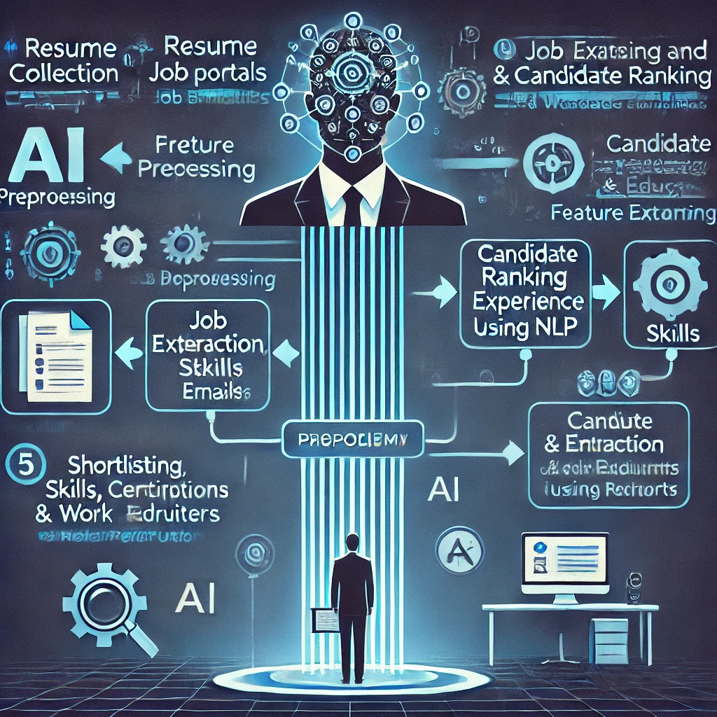

**Fig2:- Methodology of AI Resume Scanning and Candidate Ranking System**

**CHAPTER 4**

**Implementation and Result**

* 1. 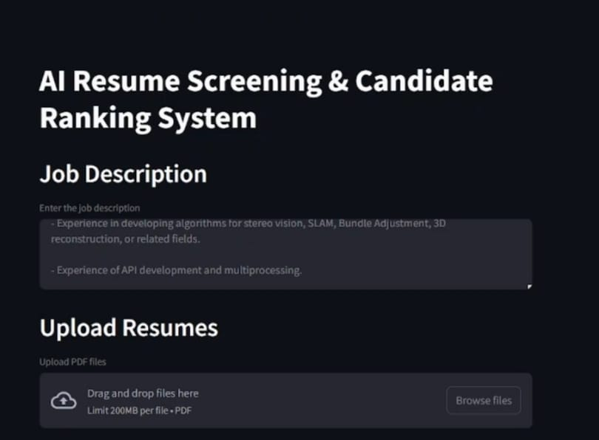 **Snap Shots of Result:**

**Fig3:-output 1 of AI Resume Scanning and Candidate Ranking System**

The interface includes sections for entering a job description and uploading resumes in PDF format. The design is dark-themed with clear labels, making it easy to use. The job description area allows users to input specific requirements, while the resume upload section supports drag-and-drop functionality with a 200MB file limit. The overall layout appears intuitive, enhancing the candidate screening process through AI-based automation.

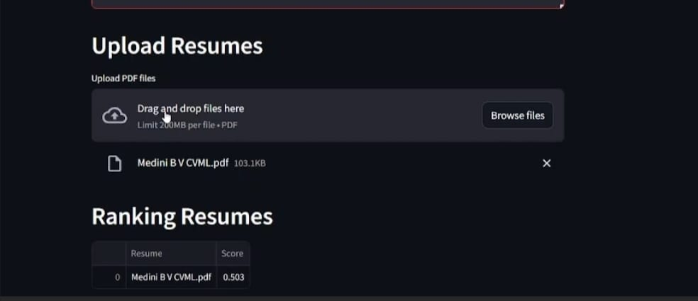**Fig:- output 2 of AI Resume Scanning and Candidate Ranking System**

It features an upload section where users can drag and drop PDF resumes or browse files manually. A resume named "Medini B V CVML.pdf" has been uploaded, with a file size of 103.1 KB. Below this, a ranking system displays the resume with a score of 0.503, indicating that the AI has evaluated the document based on the provided job description. The interface is clean and user-friendly, designed for efficient candidate assessment**.**

* 1. **GitHub Link for Code:**

[**https://github.com/bhoomikar386/Resume-screening-and-scanning.git**](https://github.com/bhoomikar386/Resume-screening-and-scanning.git)

**CHAPTER 5**

**Discussion and Conclusion**

**5.1 Future Work**

While the **AI Resume Scanning and Candidate Ranking System** enhances the hiring process, there are several areas for improvement and expansion:

* **Integration with Applicant Tracking Systems (ATS):** Future versions can be designed to seamlessly integrate with existing ATS platforms used by organizations for better workflow management.
* **Enhanced Soft Skills Evaluation:** Incorporating **Natural Language Processing (NLP) and Sentiment Analysis** to assess communication skills, leadership qualities, and personality traits based on resume content or cover letters.
* **Bias Reduction Techniques:** Further refinement of **Fair AI models** to minimize discrimination based on gender, ethnicity, or other sensitive factors in hiring decisions.
* **Interview and Assessment Integration:** AI-driven **video interview analysis** using facial expression recognition and speech sentiment analysis for holistic candidate evaluation.
* **Multi-Language Support:** Expanding NLP capabilities to process resumes in multiple languages, improving accessibility for international job markets.
* **Real-Time Job Market Analysis:** Implementing a **real-time labor market analysis feature** that suggests industry trends and in-demand skills to both recruiters and candidates.
* **Customizable AI Ranking Models:** Allowing recruiters to **adjust ranking algorithms dynamically** based on company-specific hiring preferences.

**5.2 Conclusion**

The **AI Resume Scanning and Candidate Ranking System** presents an innovative approach to automating and optimizing the recruitment process. By leveraging **Artificial Intelligence (AI), Machine Learning (ML), and Natural Language Processing (NLP)**, this system significantly reduces manual effort, improves candidate evaluation accuracy, and minimizes human bias in hiring decisions.

The project successfully achieves the following:

* Efficiently **extracts key candidate details** from resumes.
* Uses **AI-driven ranking algorithms** to shortlist candidates based on job-specific criteria.
* Provides **fairer and faster hiring** while reducing the burden on HR teams.

This system contributes to modernizing recruitment, ensuring organizations make **data-driven hiring decisions** while maintaining fairness and efficiency. With further enhancements in AI and recruitment technologies, this model can revolutionize the way companies approach talent acquisition in the future.

**REFERENCES**

1. Ming-Hsuan Yang, David J. Kriegman, Narendra Ahuja, “Detecting Faces in Images: A Survey”, IEEE Transactions on Pattern Analysis and Machine Intelligence, Volume. 24, No. 1, 2002.